1. **Create a class called "Item" which has the following properties: a. Name of the item b. Price of the item Create an event in Item class that is fired whenever price changes through the property created. Create a console application that will display the new price of the Item using an EventHandler.**

**Code:**

using System;

namespace q1

{

public delegate void PriceChangedEventHandler(double price);

class Item

{

private string name;

private double price;

public event PriceChangedEventHandler PriceChanged;

public string Name { get; set; }

public double Price {

get

{

return price;

}

set

{

price = value;

if (PriceChanged != null)

PriceChanged(value);

}

}

}

class Program

{

static void Main(string[] args)

{

Item item1 = new Item();

Console.WriteLine("Enter the product name and price");

item1.Name = Console.ReadLine();

double price;

double.TryParse(Console.ReadLine(), out price);

item1.Price = price;

item1.PriceChanged += ChangeDetected; //Linking Event Handler to Event

item1.Price = item1.Price * 2;

}

//Event handler

public static void ChangeDetected(double price)

{

Console.WriteLine("New price is " + price);

}

}

}

**Output:**

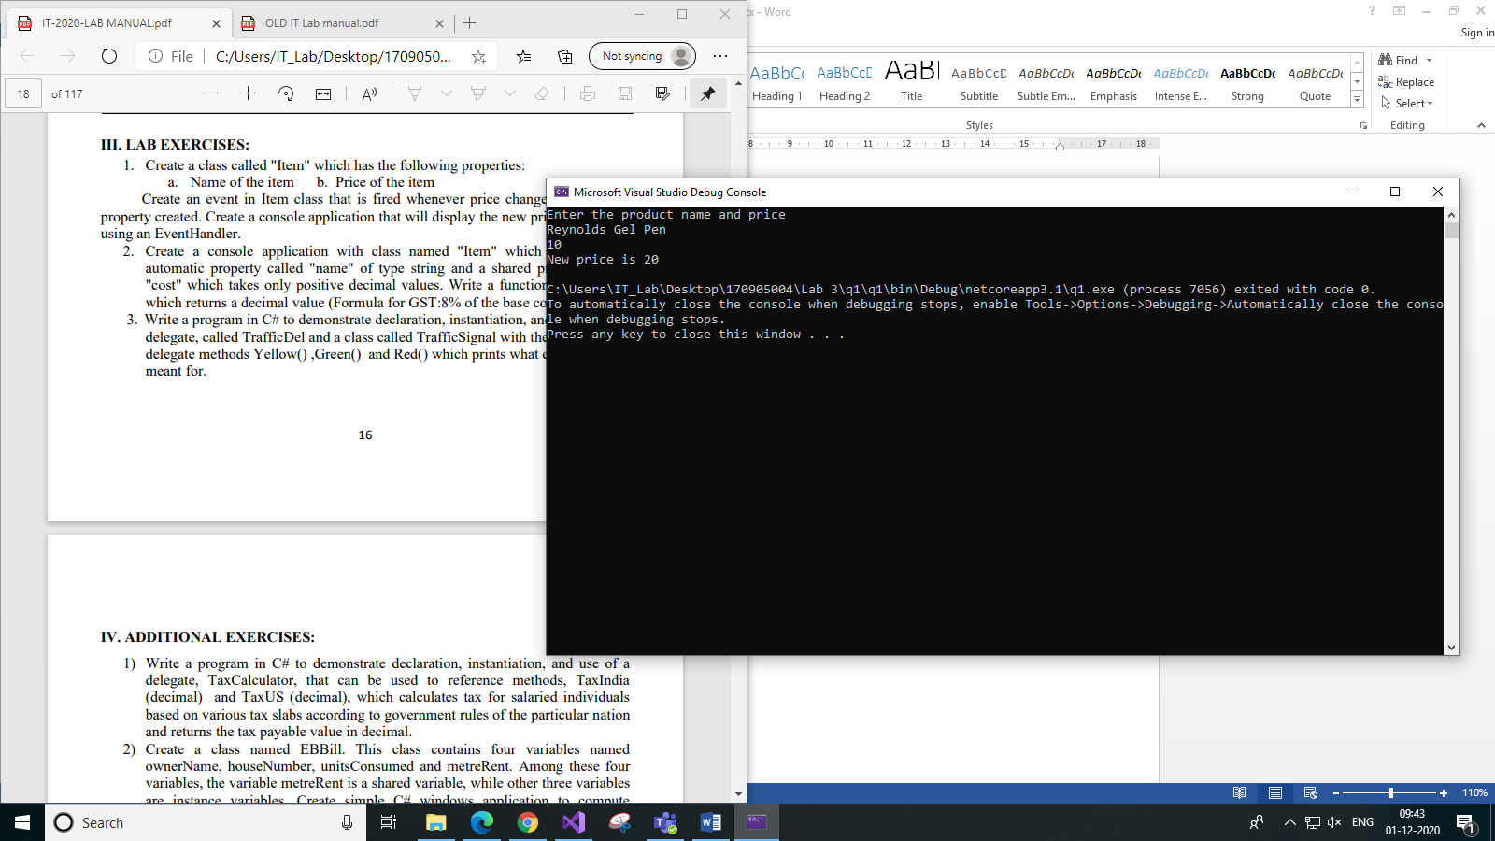

1. **Create a console application with class named "Item" which contains one automatic property called "name" of type string and a shared property called "cost" which takes only positive decimal values. Write a function "CalcGst( )" which returns a decimal value (Formula for GST:8% of the base cost).**

**Code:**

using System;

namespace q2

{

class Item

{

private static decimal cost;

public static decimal Cost

{

get

{

return cost;

}

set

{

//Ensure it is a positive decimal

if (value < 0)

{

Console.WriteLine("Invalid. Only positive decimals accepted.");

}

else

cost = value;

}

}

public string Name { get; set; }

public decimal CalcGst()

{

return 0.08M * cost;

}

}

class Program

{

static void Main(string[] args)

{

Item item = new Item();

Console.WriteLine("Enter item name and cost: ");

item.Name = Console.ReadLine();

decimal cost;

//Check if input is decimal

Decimal.TryParse(Console.ReadLine(), out cost);

Item.Cost = cost;

Console.WriteLine("GST of {0} costing {1} is {2} ", item.Name, Item.Cost, item.CalcGst());

}

}

}

**Output:**

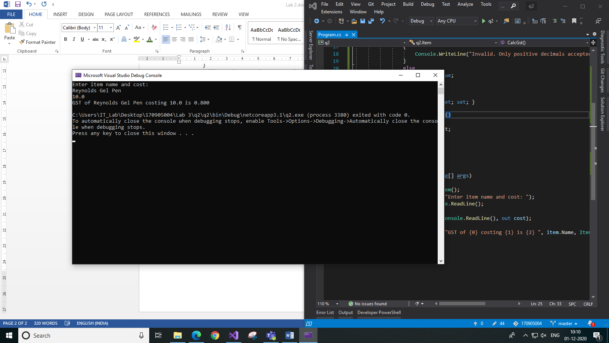

1. **Write a program in C# to demonstrate declaration, instantiation, and use of a delegate, called TrafficDel and a class called TrafficSignal with the following delegate methods Yellow() ,Green() and Red() which prints what each signal is meant for.**

**Code:**

using System;

namespace q3

{

public delegate void TrafficDel();

class TrafficSignal

{

public void Yellow()

{

Console.WriteLine("Yellow");

}

public void Green()

{

Console.WriteLine("Green");

}

public void Red()

{

Console.WriteLine("Red");

}

}

class Program

{

static void Main(string[] args)

{

//TrafficSignal class object

TrafficSignal trafficSignal = new TrafficSignal();

//Create and assign the delegate to Red delegate method and then call it

TrafficDel signalDelegate = trafficSignal.Red;

signalDelegate();

//Assign the delegate to Yellow delegate method and then call it

signalDelegate = trafficSignal.Yellow;

signalDelegate();

//Assign the delegate to Green delegate method and then call it

signalDelegate = trafficSignal.Green;

signalDelegate();

}

}

}

**Output:**

